Competitive Shooters of Lake Norman USPSA February 13th, 2026
COURSE DESIGNER: Ryan Christenson

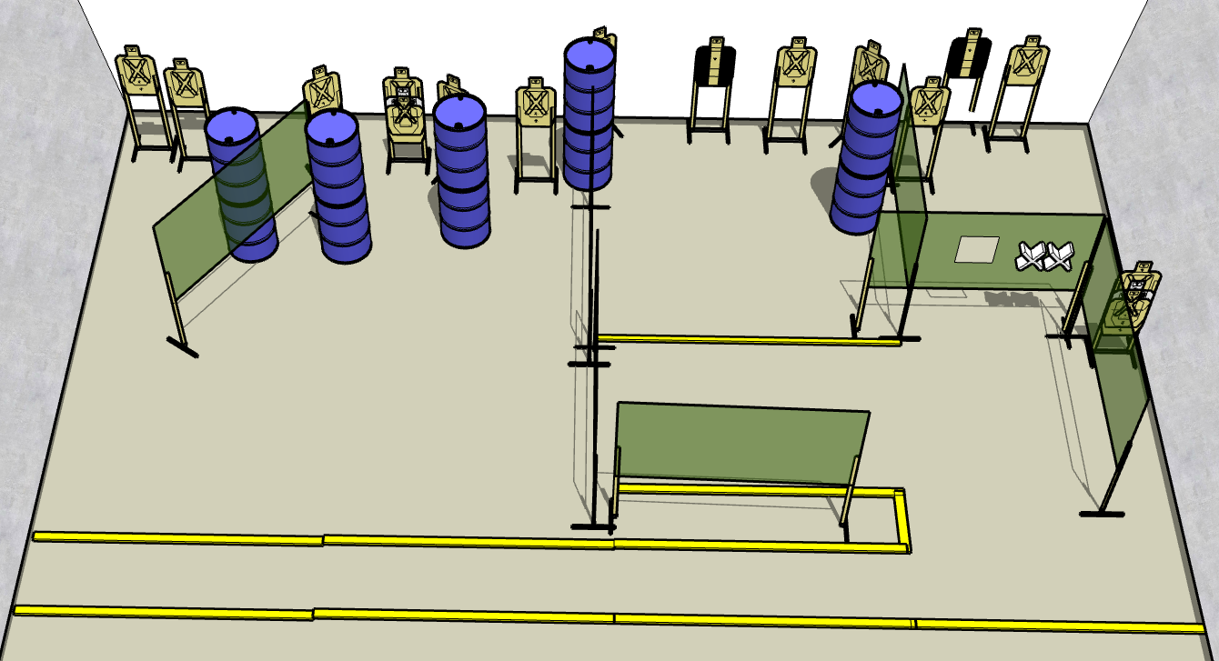

Stage 1 – Get to the chopper!
30 rounds, 150 points, Comstock
There are 15 cardboard targets with some no-shoots.
Starting anywhere.
Handgun is unloaded and holstered. Wrists below belt.
PCC is unloaded held in both hands stock touching belt.
On the audible start signal, engage targets from within the shooting area.
Stage 3 – There's something out there waiting for us... and it ain't no man.
32 rounds, 160 points, Comstock
There are 16 cardboard targets with some no-shoots.
Starting with palms touching marks. PCC muzzle touching right mark
Handgun is loaded and holstered.
PCC is loaded held in both hands.

